Blockchain Platform Comparison Analysis

|  |  |  |  |
| --- | --- | --- | --- |
| **Blockchain Name** | **Ethereum** | **Hyperledger Fabric** | **R3 Corda** |
| **Type** | Public | Private | Consortium |
| **Consensus Mechanism** | Proof of Stake (PoS) | Pluggable (PBFT, Raft) | Notary-based consensus |
| **Permission Model** | Open/  Permissionless | Permissioned | Permissioned |
| **Speed/Throughput** | ~15 TPS | 3,500+ TPS | 170 TPS |
| **Smart Contract Support** | Yes - Solidity, Vyper | Yes - Go, Node.js, Java | Yes - Kotlin, Java |
| **Token Support** | Native (ETH) + ERC tokens | No native token | No native token |
| **Typical Use Case** | DeFi, NFTs, DApps | Enterprise solutions, supply chain | Financial services, trade finance |
| **Notable Technical Feature** | EVM compatibility, largest developer ecosystem | Modular architecture, channels for privacy | UTXO model, point-to-point transactions |

**1. Platform Comparison Table –**

**2. Technical Capabilities Analysis**

**i. Ethereum:**

**Architecture & Consensus:** Ethereum operates on a fully decentralized network with Proof of Stake consensus, utilizing validators who stake ETH to secure the network. The Ethereum Virtual Machine (EVM) provides a Turing-complete execution environment, enabling complex smart contracts. Layer 2 solutions like Polygon and Optimism address scalability through rollup technology, increasing effective throughput to thousands of TPS while maintaining security.

**Development Ecosystem:** The platform boasts the most mature development environment with comprehensive tooling including Remix IDE, Truffle, and Hardhat. Smart contracts are primarily written in Solidity, with extensive libraries like OpenZeppelin providing battle-tested security patterns. The platform supports multiple token standards (ERC-20, ERC-721, ERC-1155) enabling diverse tokenization models.

**Limitations:** Base layer scalability remains constrained at ~15 TPS, leading to network congestion and high gas fees during peak usage. The permissionless nature, while promoting decentralization, can introduce security risks from malicious actors and makes governance challenging.

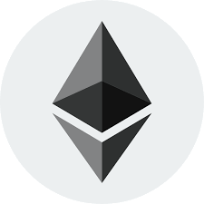

**ii. Hyperledger Fabric:**

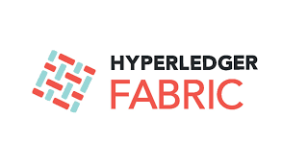

**Modular Architecture:** Fabric's unique selling proposition lies in its modular design allowing organizations to customize consensus mechanisms, membership services, and endorsement policies. The ordering service can utilize different algorithms (Solo, Kafka, Raft) based on network requirements. Channels provide data isolation, enabling multiple parallel blockchains within a single network.

**Performance & Scalability:** Achieves superior throughput through execute-order-validate architecture, where transactions are executed before ordering, eliminating invalid transactions early. The system supports horizontal scaling through multiple endorsing peers and can handle complex business logic through chaincode (smart contracts) written in Go, Node.js, or Java.

**Enterprise Features:** Membership Service Provider (MSP) provides robust identity management with certificate authority integration. Private data collections allow confidential information sharing between authorized subsets of channel members. The absence of native cryptocurrency simplifies regulatory compliance and reduces operational overhead.

**Limitations:** Requires significant infrastructure setup and ongoing network management. The permissioned nature limits accessibility and requires trust in network operators.

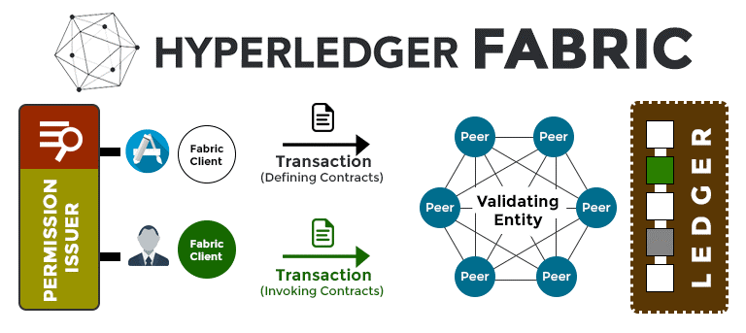

iii. **R3 Corda**



**Unique Transaction Model:** Corda employs a UTXO-based model where states are consumed and created rather than maintaining global state. This approach ensures data privacy as transactions are only shared with relevant parties. The platform uses a notary service to prevent double-spending while maintaining transaction privacy.

**Financial Services Optimization:** Purpose-built for financial applications with features like automatic Know Your Customer (KYC) integration, regulatory reporting capabilities, and legal prose contracts that bridge legal and code implementations. The platform supports complex financial instruments including derivatives, loans, and trade finance instruments.

**Consensus & Governance:** Implements pluggable consensus through notary services, allowing different consensus mechanisms for different transaction types. The network can operate with multiple notary pools, providing redundancy and specialized services for specific use cases.

**Privacy & Compliance:** Transactions are peer-to-peer, with only relevant parties seeing transaction details. Built-in integration with existing banking systems and regulatory frameworks. The platform provides audit trails while maintaining transactional privacy.



**3. Platform Recommendations**

**i. For a Decentralized App: Ethereum**

**Technical Justification:** Ethereum's permissionless architecture is fundamental for true decentralization, eliminating single points of failure and censorship resistance. The EVM provides deterministic execution across all nodes, ensuring consistent application behavior globally. The extensive developer ecosystem offers mature tooling, comprehensive documentation, and proven security patterns through audited smart contract libraries.

**Ecosystem Advantages:** Access to decentralized infrastructure including IPFS for storage, Chainlink for oracles, and The Graph for indexing. The platform's native token economics enable sophisticated incentive mechanisms through staking, governance tokens, and automated market makers. Layer 2 solutions like Arbitrum and Optimism provide scalability while inheriting Ethereum's security guarantees.

**Considerations:** Gas fee volatility requires careful UX design and potentially implementing meta-transactions or gasless interactions. Smart contract upgradability must be planned carefully, often requiring proxy patterns or governance mechanisms for protocol evolution.

.

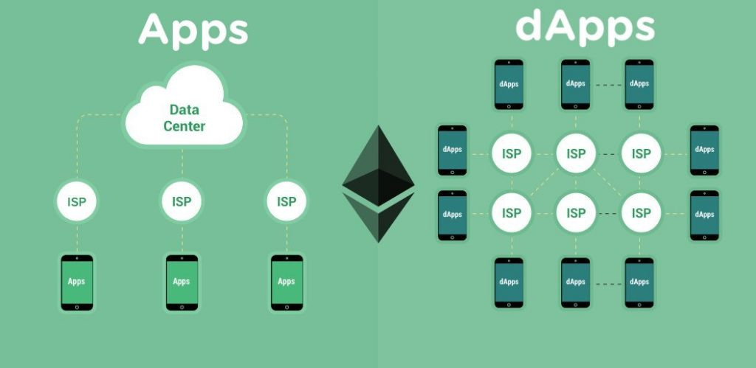

**ii. For Supply Chain Among Known Partners:** **Hyperledger Fabric**

**Technical Superiority:** Fabric's channel architecture allows segregation of sensitive business data while maintaining shared operational visibility. Private data collections enable confidential information sharing (supplier pricing, quality metrics) between relevant parties without exposing data to all network participants. The ordering service provides finality guarantees essential for supply chain commitments.

**Scalability & Performance:** The execute-order-validate model eliminates computational waste by validating transactions before committing to the ledger. Endorsement policies can be customized per transaction type, allowing different validation requirements for different supply chain events (shipping vs. quality inspection). The system supports high-frequency updates necessary for real-time tracking.

**Integration Capabilities:** Chaincode can integrate with existing enterprise systems (ERP, WMS, CRM) through RESTful APIs. The modular architecture allows integration with IoT devices for automated data collection. Certificate authority integration ensures proper identity management for all supply chain participants.

**Business Logic:** Support for complex multi-party agreements including conditional payments, quality-based settlements, and automated compliance reporting. The platform can handle sophisticated workflows like multi-signature approvals for high-value shipments.

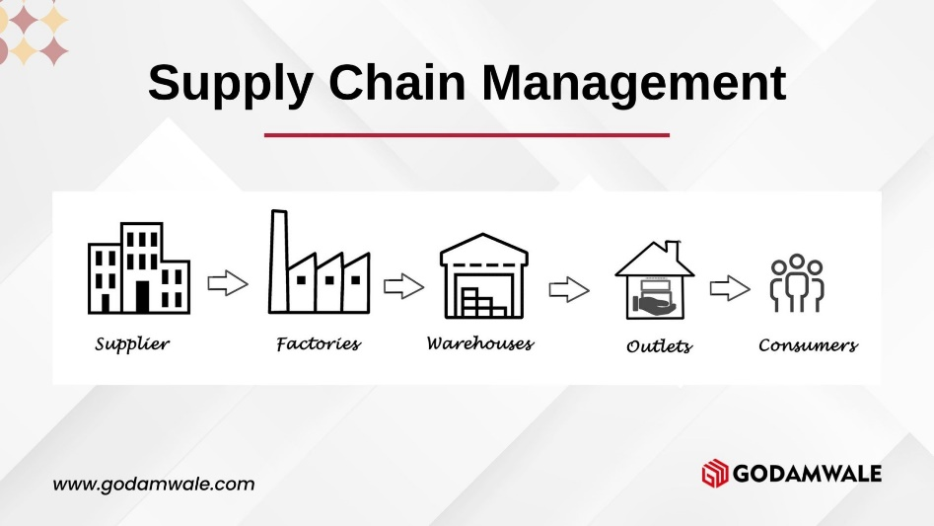

**iii. For Inter-bank Financial Application:** **R3 Corda**

**Regulatory Compliance:** Built-in support for financial regulations including Basel III, MiFID II, and PSD2 compliance frameworks. The platform provides comprehensive audit trails while maintaining transaction privacy through selective disclosure. Legal prose contracts ensure enforceability in traditional legal systems, crucial for inter-bank agreements.

**Transaction Privacy:** Point-to-point transaction sharing ensures sensitive financial data remains confidential between relevant parties. The UTXO model prevents information leakage through global state analysis. Notary services provide double-spend protection without requiring global consensus, maintaining privacy while ensuring integrity.

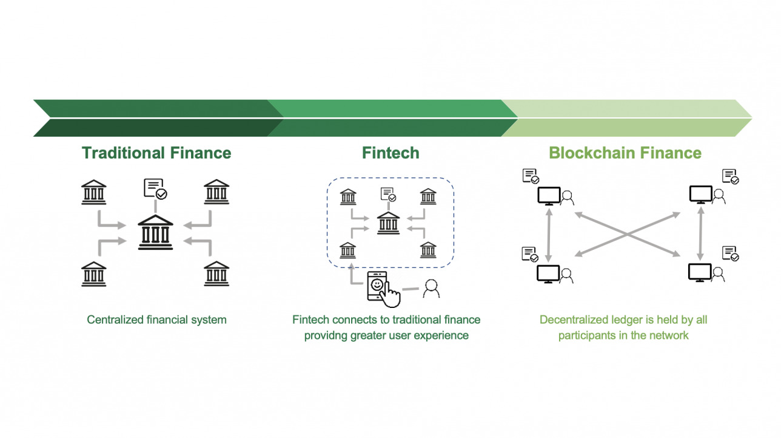

**Financial Instruments Support:** Native support for complex financial products including derivatives, letters of credit, and multi-currency transactions. The platform handles sophisticated settlement mechanisms including delivery versus payment (DVP) and payment versus payment (PVP) scenarios essential for inter-bank operations.

**Operational Integration:** Seamless integration with existing banking infrastructure including SWIFT networks, core banking systems, and regulatory reporting platforms. The platform supports batch processing for high-volume transactions while maintaining real-time capabilities for time-sensitive operations.

**Risk Management:** Built-in support for collateral management, margin calculations, and credit risk assessment. The platform can implement sophisticated netting algorithms for multi-party settlement scenarios, reducing counterparty risk and operational overhead.